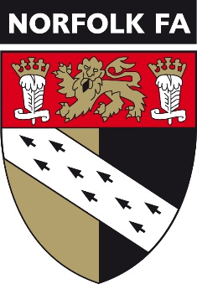**The Mid Norfolk Youth League** 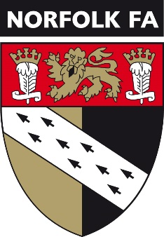

**Cup Rules 2024-2025**

***Control of Competition***

The management of the competition shall be vested in the management committee of the league, and they will have the power to deal with any matter for which no specific provision is made in these rules, or the rules of the league.

***Organisation of the Competition***

Each age group shall be conducted either as a “knock out” or “group(s)”.

All Ties to be played on the arranged date except where the following may apply.

(i) Entry into a National or County FA Competition

(ii) Providing 3 or more players for League Rep matches or County School team

(iii) Any school activity under League Rule 18(N)(i) involving 3 players or more

(iv) Any official Scout parade i.e. St George’s Day, Remembrance Sunday

(v) On instruction from the Management Committee via the League Secretary

(vi) Adverse weather conditions

For points (i), (ii), (iii) & (iv) above notification from the club secretary to the League Secretary must be made and received by the League Secretary at least 7 clear days prior to the date of the game.

FAILURE to adhere to any of the above may see the offending team excluded from the competition.

All Mid Norfolk Youth League ‘knock out’ cup ties to be concluded on the day.

In the event of scores being level at the end of normal time a penalty shoot-out, in accordance with the Laws of the Game, will decide the winners of the tie.

All Mid Norfolk Youth League ‘group stage’ cup ties will be as per a normal league basis. If there is only one group, the top 2 will play in the final.

If there is more than one group, the League Secretary will communicate the format to the Club Secretaries of the teams involved.

Goal difference will be used to decide positions if teams are tied in a group.

Where the teams cannot be separated by the use of goal difference a play off may take place. This will be communicated by the League Secretary to the Club Secretaries of the teams involved.

In the event of a team reaching a cup final they will be expected to supply a match ball in good condition for use, which will be returned at the end of the game.

A team that reaches the final must submit a list of the squad they will be using on the day, no later than 48 hours before the kick-off time, to the cup coordinator.

***Provisions for removal/exclusion from the competition***

1. A team found to have played an ineligible player may be removed from the competition and fined up to £50. If the game is ordered to be replayed, then the offending club may also be ordered to pay the expenses incurred.
2. In the event of club failing to play a cup fixture without satisfactory explanation, the offending club will be dealt with by the management committee which may include forfeiting the match and/or a fine of up to £50.
3. The Final date and venue will be arranged by the cup coordinator.

***Reporting Results***

1. Teams will confirm the result of the game via text within 24 hours of the games completion, for the avoidance of doubt this is the SMS text received from the fulltime system.
2. Teams must complete fulltime sheets by the Tuesday after the game has been played or they shall be fined in accordance with the fine structure for league games.

***Club Colours***

If there is a colour clash, then the team who are named first on the fixture, normally known as the home team, will change to avoid a colour clash.

***Eligibility of Players***

1. A player may not play for a team if they have played in a previous round of a league/sub cup for another team in any age group, except in exceptional circumstances, agreed by the management committee before the game starts.
2. No player may play in the Semi-Final or Final unless they have played in at least 3 League and/or Cup games or was registered to the team prior to October 1st in the current playing season. In exceptional circumstances special permission may be obtained from the management committee to play an otherwise ineligible player. Applications for special permission must be submitted in writing to the League Secretary at least 7 full days prior to the day of the game.

***Provisions Concerning Match Officials***

1. The management committee shall endeavour to facilitate the official appointment of as many referees and assistant referees for cup matches as possible. Otherwise Rule 13 of the league rules shall apply.
2. In all rounds except the final, the match fees shall be split between both teams.

***Trophies***

Winning teams must return the trophy by 1st February of the following season or shall be fined up to £50.